05 Nights & 06 Days Kerala Tour

Day 01 Arrive Cochin

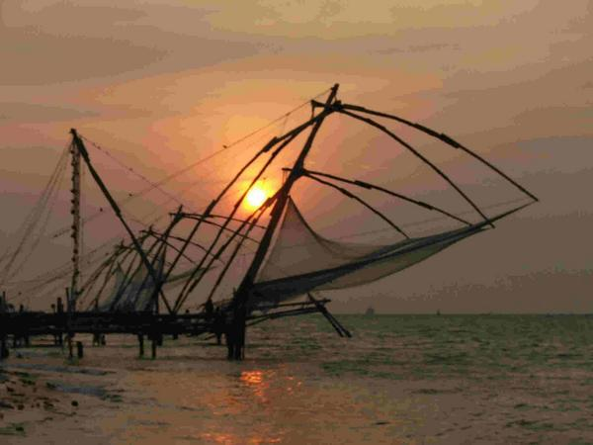
Arrive Cochin. You will be met by our representative at the arrivals lounge and escorted till your check in at Hotel.

Cochin, originally built by the Portuguese, has a natural harbour with lagoons, canals and fishing hamlets. One of the three biggest ports on the West Coast, it is also an industrially developed area. The coir industry is of special importance. There is golf and swimming for the sporty tourist. An excursion by boat through the backwaters is enchanting

Overnight at hotel.

Day 02 Cochin – Kumarkom (by surface)

Morning after breakfast proceed for city tour of Cochin.

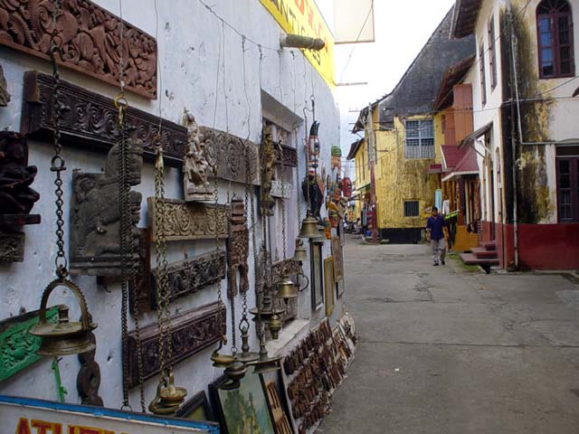
Later proceed for half day city tour visit the Mattancherry Dutch Palace - open from 10.00 to 15.00 hrs.(closed on Fridays and public holidays), which was built by the Portuguese in 1555 and renovated by the Dutch in 1663. In the ancient rooms are 17th century murals that relate in vibrant colour the story of the epic Ramayana. Visit a Jewish Synagogue - open 10.00 to 12.00 hrs. & 15.00 to 17.00 hrs.(closed on all Saturdays and Jewish holidays) in Jew Town and Fort Cochin Area - Legend dates Jewish trade with Kerala from the times of King Solomon. There are a couple of streets of picture-postcard houses out of another age, in 17th century Dutch and traditional Kerala styles. Visit St. Francis Church - open from 09.00 to 13.00 hrs. and 14.30 to 17.30 hrs.(closed for visitors on Sundays from 08.00 to 11.00 hrs.) the oldest European Church in India. It has several antiquities including a wealth of records. These include a palm-leaf title deed the local Raja gave the Portuguese in 1503. See the Chinese Fishing Nets, along the tip of Fort Cochin unique to this part of Kerala and living symbols of a centuries-old Chinese influence on this coast..

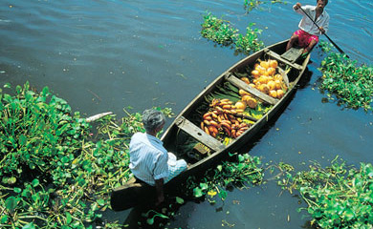
Later drive to Kumarkom

Kumarakom, a quaint little place on the backwaters of Kerala. It lies on the eastern shore of the Vembanad Lake, which is a bird sanctuary. Waterfowl, cuckoo and wild duck can be seen in abundance here. In winter, large flocks of migratory wild duck from Siberia come in spectacular formation to roost. Kumarakom lies in a timeless world of gentle, unhurried activity.

On arrival transfer, Check in at hotel.

Overnight at hotel.

Day .03 Kumarkom – Periyar ( by surface )

Morning after breakfast Drive to Periyar

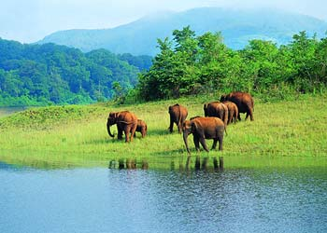
On arrival transfer check in at hotel.

Afternoon enjoy boat ride on Lake Periyar to view the wild life

Periyar Park encompasses 26 sq. km. artificial lake Take a boat ride on the lake to view wild life and water birds. Herds of elephants and bison come to the lake. Spotted deer and sambhar are also found here.

Overnight at hotel.

Day 04 Periyar – Marari

Morning after breakfast drive to Marari.

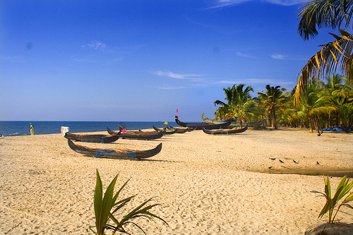
Especially designed for the discerning traveler who is seeking that something extra special in beautiful, natural surroundings. Marari originates from the Mararikulam, a picturesque fishing village on the Malabar Coast line.

Located in a 25 acres coconut palm grove that leads down to the Marari Beach. The brand new resort is built in the traditional style of a south Indian fishing village & comprised of 52 thatched villas. Each spacious villa is of 400 sq. feet is air-conditioned & will appointed with twin or double beds, mini bar, coffee making facility & a veranda well furnished with a ceiling fan. The attached modern bathrooms are also styled in the traditional Kerala design with an open-air courtyard complete with a Banyan tree. The resort boasts of a large pool, a restaurant where the main buffer meals are served, a bar & an amphitheatre where occasional cultural performances are organized. The “beach shacks” set amongst the palms, facing the beach serves delicious seafood.

On arrival transfer check in at hotel.

Rest of the day at leisure.

Overnight at hotel.

Day 05 In Marari

Day free at leisure.

Overnight at hotel.

Day 06 Marari - Cochin (By surface)
Leave Cochin

Morning transfer to Cochin airport to connect flight to onward destination.

